Efficiency Benchmark Audit Report
Vectorized Pandas vs Iterative Python Loop
Dataset: 100,000 Rows | AI/ML Internship-Prosensia
Date: 03 June 2026

1. Overview
This report documents the efficiency benchmark audit conducted on Day 2 of the AI/ML internship at Prosensia. The objective was to compare two approaches to data cleaning on a 100,000 row dataset: a standard Python iterative for loop and a fully vectorized Pandas operation.
The report also provides a mathematical justification for the choice of outlier detection method, comparing Z-Score Standardization against the Interquartile Range (IQR) method.

2. Dataset Description
A synthetic dataset of 100,000 rows was generated with three columns: User_ID, Age, and Score. The dataset was intentionally contaminated to simulate real-world dirty data conditions:
- 5,000 NaN values injected into the Age column (~5% missing)
- 5,000 NaN values injected into the Score column (~5% missing)
- 200 extreme outliers injected into Age (values like 150, -10, 200)
- 200 extreme outliers injected into Score (values like 500, -100, 999)

This mirrors conditions commonly encountered in production ML pipelines, where sensor errors, form submission bugs, or data entry mistakes produce corrupted records.

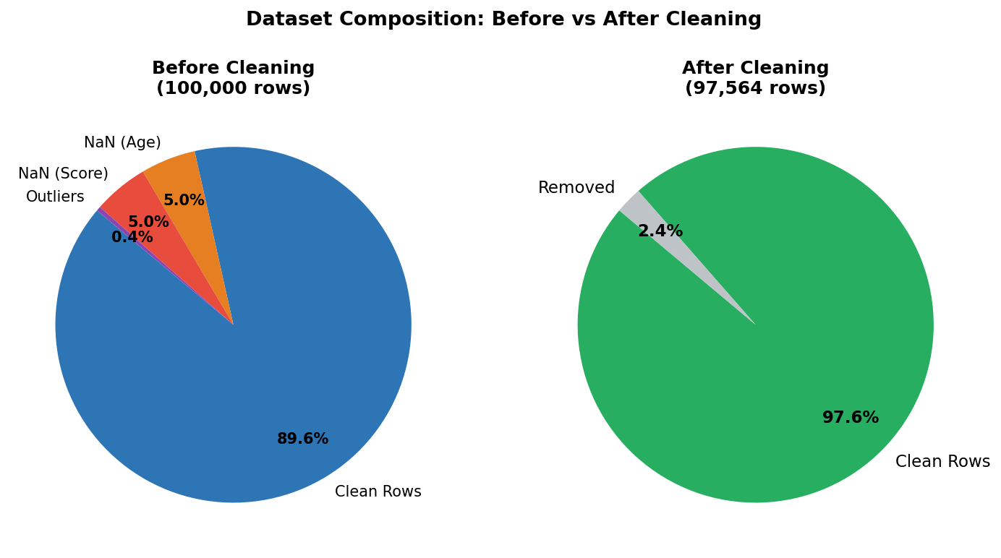

After cleaning, the pipeline retained 97,564 rows removing 2,436 outlier records. All NaN values were filled using column median values before outlier removal.

3. Execution Time Benchmark

What Was Tested
Both methods performed the same task, scanning 100,000 rows and replacing NaN values in the Age and Score columns with the column median. The only difference was the implementation approach.

The iterative loop processed each row one at a time using Python's native for-loop and .loc[] accessor. The vectorized approach used Pandas' .fillna() method, which delegates the operation to NumPy's C-compiled backend and processes the entire column in a single array operation.

Results
Method | Execution Time | Speedup
Iterative For-Loop | 5.3384 seconds | 1x (baseline)
Vectorized Pandas (.fillna) | 0.0063 seconds | 851.7x faster

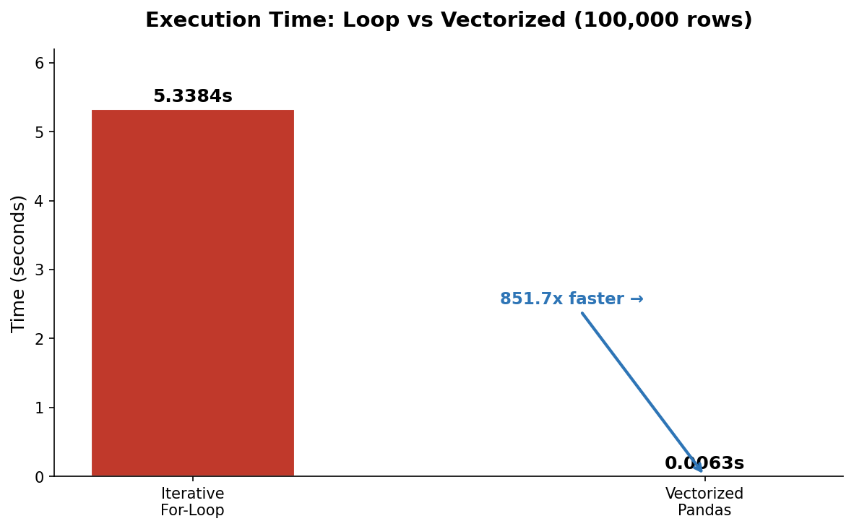

Why Is the Loop So Much Slower?
Python for-loops are slow for numerical operations because of how Python works internally. Every single iteration goes through the Python interpreter, which means:
- Each row access via .loc[] triggers a full lookup in the DataFrame index
- Python checks the data type of every value at every step (dynamic typing overhead)
- The Global Interpreter Lock (GIL) prevents parallel execution
- No CPU-level vectorization (SIMD) can be applied to interpreted row-by-row code

Pandas vectorized operations bypass all of this. When you call .fillna(), Pandas passes the entire column as a NumPy array to a pre-compiled C function. That function runs directly on the CPU, processes all 100,000 values in a single memory pass, and returns the result. There is zero Python overhead per row.

This is why the speedup is not 2x or 10x but 851x. The loop was not just slower it was operating in a completely different computational model.

4. Outlier Detection: Z-Score vs IQR
Two standard methods exist for identifying and removing statistical outliers from numerical data. Choosing the wrong method for a given dataset can result in either missing real outliers or incorrectly removing valid data points.

Z-Score Standardization
The Z-score measures how far a value is from the mean of its distribution, expressed in units of standard deviations. The formula is:
Z = (X − μ) / σ
Where X is the data point, μ (mu) is the column mean, and σ (sigma) is the standard deviation. A value is classified as an outlier if its absolute Z-score exceeds 3, meaning it sits more than 3 standard deviations away from the average.

Core assumptions and limitations:
- Assumes the data follows a normal (bell-curve) distribution, this is the critical assumption
- The mean and standard deviation are themselves sensitive to extreme values, meaning one severe outlier inflates both, which raises the threshold and can hide other outliers
- Works reliably on clean, symmetric, normally distributed datasets
- Unreliable on skewed data or datasets with heavy contamination

IQR Method
IQR is a percentile-based method that focuses on the spread of the middle 50% of the data, completely ignoring the extreme ends. It is calculated as:
IQR = Q3 − Q1
Lower Bound = Q1 − (1.5 × IQR)
Upper Bound = Q3 + (1.5 × IQR)
Any value falling outside these bounds is removed. Q1 is the 25th percentile, and Q3 is the 75th percentile of the data. The multiplier 1.5 was established by statistician John Tukey and is the standard threshold used in box plots.

Core strengths:
- Non-parametric does not assume the shape of the distribution
- Robust to contamination extreme outliers do not shift Q1 or Q3, so the boundaries remain stable
- Works correctly on skewed, asymmetric, or unknown distributions
- The standard method used in exploratory data analysis and ML data preprocessing

Side-by-Side Comparison
Property | Z-Score | IQR
Distribution assumption | Requires normal distribution | No assumption required
Sensitivity to outliers | High — mean/std shift with outliers | Low percentiles are stable
Formula basis | Mean and Standard Deviation | Q1, Q3, and IQR
Outlier threshold | |Z| > 3.0 | Outside Q1/Q3 ± 1.5 × IQR
Best use case | Clean, symmetric, known distributions | Real-world, skewed, or contaminated data
Used in this pipeline | No | Yes

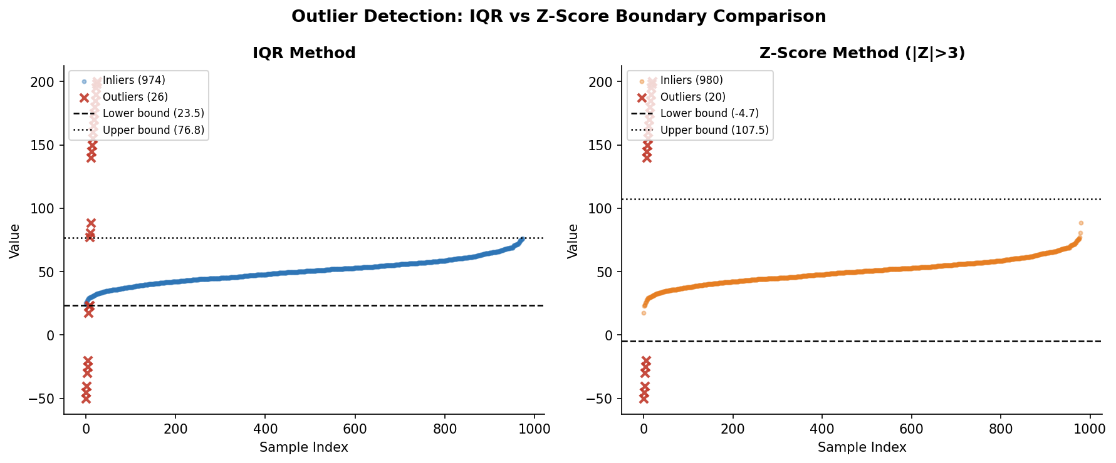

Why IQR Was the Correct Choice
Our dataset had extreme injected outliers (Age = 150, 200; Score = 500, 999). These values are so far from the real data that they would have significantly inflated the mean and standard deviation if the Z-score were applied. This inflation raises the detection threshold, which could cause the method to miss other, less extreme outliers.

IQR was the right choice because:
- The injected extreme values had zero effect on Q1 or Q3 percentiles are immune to extreme contamination
- No assumption about normal distribution was needed
- The method correctly identified and removed 2,436 rows (2.4% of the dataset), consistent with the injection rate
- The remaining 97,564 rows represent statistically clean data within realistic age and score ranges

5. Summary and Conclusions
This audit established two key engineering findings:

Finding 1:Vectorization is not optional:
An 851.7x speedup over a for-loop is not a minor optimization. At 100,000 rows, the loop took 5.3 seconds. At 10 million rows, that becomes 9 minutes. Vectorized Pandas at the same scale takes under a second. Any production ML pipeline that uses for-loops for numerical operations on DataFrames is fundamentally broken at scale.

Finding 2 :Outlier method selection is data-dependent:
The Z-score is not universally applicable. It is a valid method specifically for normally distributed, uncontaminated data. For real-world pipelines where the distribution is unknown or contaminated, IQR is the safer, more robust default. The choice of method directly affects which rows survive the cleaning step, and therefore what the model trains on.

